**IT 411: IT CAPSTONE PROJECT 2**

**Requirements in the Preparation of the Final Manuscript**

1. **Type of paper:** The paper required must conform to the following requirements:

• Color: White

• Size: 8 ½ by 11 inches

• Substance 20 or higher GSM

1. **Text, tables, and figures must be presented in black ink only**
2. **Page Margins**

- Left margin - 1 ½ inches

- Other sides - 1 inch

1. All signatures on the approval page must be original and signed using an ink pen. The document must be signed by the Chairman of the Panel, the panel members, the adviser, and the College Dean.
2. **Text/Font Styles and Sizes**

∙ Serif type font style is Times New Roman 13.

∙ Figures and tables - font size shall not be smaller than 9 points.

1. **Spacing, Paragraphing and Indentions**

∙ The general text of the manuscript shall be **double spaced**

∙ Single-space should be used in the:

o Tables with more than ten (10) rows

o Bibliographic entries

∙ Paragraph indentions shall be five (5) spaces or one standard tab.

∙ Additional indentations on the first line should be done for sub-topics or sub- sections.

1. **Page Numbering**

∙ The preliminary pages are numbered in consecutive lower case Roman numerals. (i, ii, iii, …)

∙ These should be centered at the bottom.

∙ The text and all reference pages, including the appendices, are numbered consecutively in Arabic numbers, beginning with 1 on the first page of the text.

∙ The title page segregating each chapter and major section, is counted but not numbered.

1. **Preparation of Tables**

∙ Every table should be given a number and should be cited in the text by that number, either directly or parenthetically.

∙ In presenting any tables, the introduction in text form should come first before displaying the table, followed by the discussion.

. Avoid using the reference “above”or “below”, instead refer to them with the Table number. **Introduce. Display. Discuss**

∙ numbering of tables should be chronologically continued through the text or the whole book. Arabic numerals are used. (Table 1, Table 2, Table 3, …)

∙ Tables must not be divided or cut into two pages.

∙ If the table will really not fit on one page, table can continue onto subsequent page/s, and the caption should not be repeated and the top line must read: Table 16 (cont'd)

∙ Use APA table format - https://www.bibliography.com/apa/apa-table-guidelines- made-simple/

Sample Table

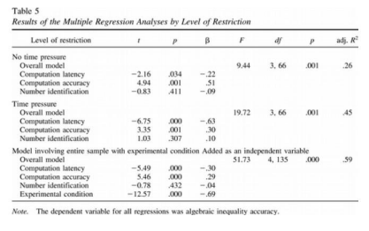

1. **Preparation of Figures**

∙ numeration of figures should be chronologically throughout the manuscript. Arabic numerals are used. (Figure 1, Figure 2, Figure 3, …)

∙ A period follows after the number of the figure.

∙ Title or caption is set below the figure.

∙ All figures must be placed immediately after the page where a particular figure number is mentioned.

∙ All figures must be well explained in the text.

∙ In presenting any figures, the introduction in text form should come first before displaying the figure followed by the discussion. Avoid using the reference “above” or “below”, instead refer to them with the Figure number. **Introduce. Display. Discuss**

∙ Figures should be oriented vertically whenever possible.

∙ Use APA figure format - https://www.bibliography.com/apa/apa-table-guidelines-made-simple/

Sample Figure

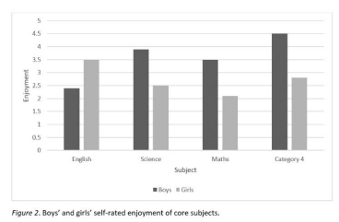

1. **Placement of Tables and Figures**

∙ All tables and figures are placed at the top or bottom portion of the page.

∙ Tables and figures must first be introduced in textual form before their presentation.

∙ The page on which the table/figure appears is numbered consecutively with the main text.

∙ This page number is used in the List of Tables or List of Figures.

1. **Arrangement of Pages and its Contents**

**Preliminary Pages**

a. Title Page.

b. Approval Sheet.

c. Abstract

∙ Length approximately 250 words

∙ Contains all sections of paper

o Introduction

o Methods in pertinent detail

o Results of testing the main hypothesis and most significant other results only

o Discussion of a sentence or two on main implications or conclusion

e. **Acknowledgement**.

f. **Dedication Page**.

**\*Use MS Word References - Table of Contents – Captions for the following:**

g. **Table of Contents**.

h. **List of Tables**

i. **List of Figures**

1. **Citation and Referencing**

∙ **Use APA 7.0 for citation and referencing**

∙ **Recent 5 years for all references including related studies and systems(2018-2023)**

o **https://owl.purdue.edu/owl/research_and_citation/apa_style/apa**

**_formatting_and_style_guide/in_text_citations_author_authors. html**

∙ **Use Mendeley Cite**

∙ Mendeley Cite will style all of your citations and bibliography according to the citation style you have selected.

∙ **Your bibliography will automatically reorder and restructure itself every time you add an additional citation** - there's no need to completely rebuild it.

o **https://www.mendeley.com/download-reference-manager/linux**

1. Use **researcher/s,** not **proponents,** not **developers**
2. **Web Hosting**

∙ Local host not allowed

∙ Free web hosting is not allowed

∙ If client is from BatStateU – you may request to ICT office ∙ For generic projects, games, mobile app with no clients – must be uploaded to a digital distribution service like Google Play Store and iOS AppStore

The main body of the BSIT Capstone Project document is divided into chapters and sub-topics or sections.

**Chapter I: INTRODUCTION**

The first chapter should describe the importance of the study, the expectations, and its impact on the specific areas once it is completed.

**Background of the Study**

∙ **Cite all your references.**

∙ This section will provide a general overview of the project.

∙ It should be able to capture the reader’s interest in the first paragraph.

∙ It should contain a rationale or justification intended to convince target users of

your system on how it can be useful or resolve the problem in question by implementing your system/project.

∙ Discuss the problem's background and why you decided to develop your project. What’s wrong with the traditional method?

∙ The necessary knowledge, programming software, APIs, hardware, etc. used in the development of the project may also be discussed.

**Objectives of the Study**

∙ The objectives of the study are the detailed statements or elaborations of the project goal.

∙ The main objective usually should be in consonance with the title of the project.

∙ The objectives should state the general and specific objectives and should be consistent with the problem.

∙ It should also be aligned with the specific functional requirements of your system/software.

∙ Specific objectives should be written by either beginning with an action verb or an infinitive statement.

∙ There should be at least one specific objective that is track-oriented.

**Significance of the Study**

The Significance of the Study section in an IT Capstone Project is a crucial component that explains the relevance and importance of the project to the field of Information Technology. It is typically written at the beginning of the project and serves as an introduction to the reader, highlighting the reasons why the project was undertaken and what value it adds to the field.

***The Significance of the Study section should include the following elements:***

1. Background Information: This section should provide a brief overview of the problem or issue that the project is attempting to address. It should also give some context about why this issue is important in the field of IT.
2. Purpose of the Project: This section should clearly state the project's purpose or objective. It should explain what the project intends to achieve and why it is essential.
3. Relevance to the Field: This section should explain how the project contributes to the field of IT. It should discuss how the project addresses current challenges or gaps in the field and how it can provide innovative solutions.
4. Potential Impact: This section should discuss the potential impact of the project on the IT industry. It should explain how the project can benefit stakeholders, organizations, or the general public.
5. Research Gap: This section should highlight the gap in research that the project aims to fill. It should explain why the current research in the field is insufficient and how the project can address this gap.

Overall, the Significance of the Study section should convince the reader of the importance of the project and demonstrate how it can make a meaningful contribution to the field of IT.

**Scope and Limitations of the Study**

This section should include a brief statement of the general purpose of the study, the target users and beneficiaries, and the period of the study.

∙ Discuss here the boundaries of the study and those likely part of the project researcher/s do not intend to accomplish (or what the design of the project inherently will not allow)

∙ Describe any global limitations or constraints that have a significant impact on the design of the system/software (and describe the associated impact).

∙ Describe any items or issues that will limit the options available to the researchers. These might include: corporate or regulatory policies; hardware limitations (timing requirements, memory requirements); interfaces to other applications; specific technologies, tools, and databases to be used; parallel operations; language requirements; communications protocols; security considerations; design conventions or programming standards. Limitations that are not readily apparent at the start of the research project may develop or become apparent as the work progresses.

**Definition of Terms**

∙ **Cite all your references.**

∙ This section provides definitions for terms used in the proposal that are unusual or not widely understood.

∙ In addition, common terms that have special meaning in the project should be defined in this section.

∙ Important terms from the title, the statement of the problem or objectives, and the paradigm should also be defined.

∙ Define terms operationally, or how you use such terms in the project.

∙ If the term is too technical, a conceptual definition can be used provided that the source/s will be properly cited.

∙ Definitions should be brief, clear, and equivocal (no double meanings).

. A brief introductory statement usually precedes the actual list of definitions, first line indented, and listed in alphabetical order.

∙ Acronyms should be spelled out fully.

∙ Must be alphabetical

**Chapter II: REVIEW OF RELATED SYSTEMS/STUDIES**

The following sections/subtopics included in this chapter are:

∙ **Cite all your references.**

∙ At least 20 related systems, 10 local studies, 20 foreign studies

∙ Avoid **n.d**. - no date

∙ Avoid using **Unpublished capstone projects/theses** (library) ∙ Use PUBLISHED RESEARCHES - Published journals

o IEEE, Science Direct, Hindawi, ACM, Springer

**Technical Background**

∙ **Cite all your references.**

∙ The technical background should contain an in-depth discussion of the technical aspects or concepts that are important in the development of the project.

∙ Align to the attainment of the objectives

∙ The technical aspects **are not limited** to the software programming or tools used, but it is about the concepts and methodologies used that contribute to the successful completion of the project.

∙ Discussions should be elaborated as much as possible in layman’s terms.

∙ However, it should not be so detailed that you end up repeating or practically lifting the discussion from different sources.

∙ It should not be so shallow or vague that the discussion becomes useless.

∙ It should contain enough detail to help the readers appreciate its application in the thesis.

∙ It must be written in narrative form.

∙ It is important that the section start with a paragraph that describes what the readers should expect.

∙ Subheadings are recommended for discussions that are substantially long.

∙ Topic items should be arranged logically by order of importance or by theme.

**Related Studies**

∙ **Cite all your references.**

∙ Related studies are the previous studies relevant to the present research.

∙ This part is an examination and discussion of the previous and present research and projects undertaken that give the researchers a better idea and have motivated them to pursue the specific field of study.

∙ It is more than an annotated bibliography or a summary, because you are organizing and presenting your sources in terms of their overall relationship to your study.

∙ This section shows evidence that you have enough knowledge of the project based on the studies conducted by previous researchers.

**Related Systems**

∙ **Cite all your references.**

∙ Related systems are the previous IT projects undertaken that were reviewed by the researchers as guide or basis for the development of their capstone project.

∙ The researchers should be able to explain how the projects have helped and what new developments will be made for the present project.

∙ One or both sections can be presented, depending on the related previous works that can be reviewed.

**Conceptual Framework**

∙ The conceptual framework gives readers a clear mental image of the fundamental organization of the study, the relationships between variables, and other relevant facts.

∙ The conceptual framework shows and illustrates all of your plans, concepts, or ideas regarding the various aspects of your research, both graphically and verbally.

Sample:

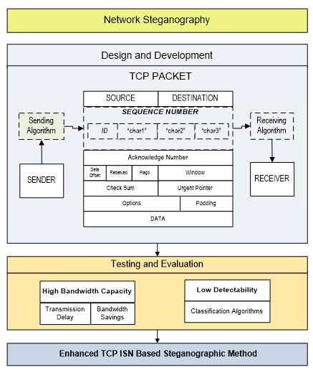

**Chapter III: DESIGN AND METHODOLOGY**

Chapter 3 shall be based on the development model.

∙ Each phase must be elaborated and discussed properly.

∙ Please note that there should be no discussion of any theory or technology in this chapter.

∙ Discuss only the processes performed for each phase.

∙ Technical descriptions/discussions should be in Chapter 2, Technical Background.

* Use web-based diagramming application in presenting diagrams:
  + LUCIDCHART
  + Diagrams.net
  + Coocoo
* Do not use PAINT or MS WORD Drawing

This is an example Software methodology model only 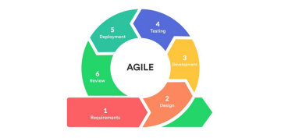

**Agile Development Model**

1. **Requirement Analysis**

*Analysis of the existing system

*Fish Bone Analysis

*System Boundary

*Hardware Requirements

*Software Requirement

*Functional Requirements

*Non- Functional Requirements

*Standards

**\*Constraints**

**\*Trade offs**

**2. DESIGN**

*System Design/ Architecture

*UML Diagrams

*Use Case

*Sequence diagrams

*Database Design

*GUI

**3. Development**

*Software

*Operating system

*Web/Mobile platform

*Database

*Subscriptions

*Hardware for development

*other technologies used in the development

**4. Testing**

* What testing and evaluation process will be done? ISO 9126 or ISO 20510:2011

* Testing Procedure

* Data Gathering

**5. Deployment**

*Deployment Process

*Maintenance Plan

**6. Risk Management Plan**

*Risk Matrix and Guide

**Chapter IV: RESULTS AND DISCUSSIONS**

In presenting this chapter, the authors should be able to address:

Appropriate diagrams, tables, charts, and/or screen shots are used in presenting the outcome or results as a **response to the objectives**.

The order of the discussion should be based on the chronology of the statement of the problems or objectives. However, it is not advisable to state the objectives or research questions in toto, as the section titles in this chapter suggest.

Instead, a more **appropriate section title** pertaining to what will be discussed and presented should be used.

**Chapter V: SUMMARY, CONCLUSIONS AND RECOMMENDATIONS**

**Summary of Findings**

* Introductory paragraph on this part may include the synopsis of the problems of research questions or the objectives and synthesized methodology.
* The salient findings for each of the specific problems/objectives should be enumerated.

**Conclusions**

* These are generalized statements from a micro to a macro level based on the answers to each of the specific objectives.
* This therefore will be also enumerated in consonance with the findings.

**Recommendations**

* should be based on the findings and conclusions
* should be feasible, workable, flexible and adaptable in a non-technical language
* should include suggestions for further studies.

**Bibliography**

* This is a list of works cited, as well as works consulted but not cited in the construction of the research or capstone project.
* **Use Mendeley Cite**
* Mendeley Cite will style all of your citations and bibliography according to the citation style you have selected.
* **Your bibliography will automatically reorder and restructure itself every time you add an additional citation** - there's no need to completely rebuild it.

**Appendices**

* An appendix or appendices should be after the bibliography. Appendices may include the following:
* Relevant Source Code
* Evaluation Tool
* Sample Input / Output / Reports
* User's Guide
* Other Relevant Documents
* Grammarian’s Certification
* Bionote

A single appendix is labeled “APPENDIX” on the contents page, with or without a title. (if using a title, it should be written as “APPENDIX: TITLE”)

**Submission of Paper (Journal) Format**

The College Research Office requires the submission of a one-page research abstract and 8-10 pages of the paper in publishable journal format. **https://www.coep.org.in/page_assets/491/IEEE_Template_4.pdf**

**Copies and Distribution of the Final Report of the IT Capstone Project**

* One hardbound for the Campus Library

**Harbound Requirements:**

https://docs.google.com/document/d/1cZwokRF7UWsoxaIEYNWc5BEFrzof22ScypjaLL-rRSo/edit?usp=sharing

**Library Requirements:**

https://docs.google.com/document/d/1_leRdKHksvsCqIJhQbJRChGJTh_xdoVU1LpV4jt 38j4/edit?usp=sharing